Lesson 1
Activity 1: Mapping Your Triple Bottom Line
Running an ethical business often means shifting from a Single Bottom Line (profit only) to a Double Bottom Line (profit + people) or Triple Bottom Line (profit + people + planet) model.
The following three tables will help you reflect on:
- How you currently operate,
- Where you want to go, and
- What first steps you can take to get there.

Part 1: Profit
Focus: Am I making profit responsibly, and reinvesting it into positive impact?
Do I make any profit? | What am I doing now? | What are my aspirations?
Am I marketing my ethical credentials to improve my profitability?
Can I invest some of my profit to improve my staff’s employment conditions?
Can I invest some of my profit to “Go Green”?
Do I donate any of my profits, time, or products?
Am I involving my staff?
Am I asking my clients to donate to good causes?
Any other?

Part 2: People
Focus: Does my business treat people fairly?
Does my business treat people fairly? | What am I doing now? | What are my aspirations?
Am I paying people fairly?
Do I have good contractual arrangements?
Is my work environment safe?
Does my workplace reflect the diversity of my environment?
Is my supply chain ethical and diverse?
Any other?

Part 3: Planet
Focus: Is my business kind to the planet?
Is my business kind to the planet? | What am I doing now? | What are my aspirations?
Am I recycling waste and reusing materials?
Am I sourcing materials that produce very little waste or produce waste that is non-toxic and biodegradable?
Am I disposing of commercial waste sustainably?
Am I/my landlord using renewable energy?
Is my workplace energy efficient?
Is my office paperless?
Do I source my supplies locally where possible?
Am I using multi-delivery services? Am I trying to be carbon neutral?
Do I make sure I use as little packaging as possible, and where I do use packaging, that it’s biodegradable?
Any other?

Lesson 2
Activity 2: Mapping Your Social Impact
Step 1 – Current Impact
List three ways your business is already making a difference (e.g., jobs created, affordable services, local partnerships).

Step 2 – Missed Opportunities
Identify at least two areas where your business could have greater impact (e.g., staff wellbeing, community links, environmental improvements).

Step 3 – Aspirations
For each area, write a practical aspiration for the next 12 months. Keep it realistic and measurable.
Fill in the given table. There are three examples for your reference:
Area | Current Impact | Aspirations (12 months)
Staff wellbeing | Provide basic training | Offer mental health support + career development
Community | Occasional donations | Set up a monthly volunteering initiative
Customers | Affordable product | Launch “buy one, donate one” scheme

Activity 3: Start an Impact Log
Choose few areas most relevant to your business (e.g., staff wellbeing, customer outcomes). What would be the indicators you would use and mention how you would collect that data.
Impact Area | Indicator | How to Collect Data | Example Evidence
Staff wellbeing | % staff reporting higher morale | Annual survey | 70% report improved job satisfaction
Community | Hours volunteered | Timesheets | 120 volunteer hours
Customers | Satisfaction score | Online survey | 4.7/5 rating

Lesson 3
Activity 4: The Wheel of Life
The Wheel of Life helps you see how balanced your life feels across different areas.
Instructions:
- Score each area (1–10): For each segment (Career, Health, Money, Relationships, etc.), mark how satisfied you feel right now (1 = very low, 10 = very high).
- Join the dots: Connect your scores around the circle to form a “wheel.”
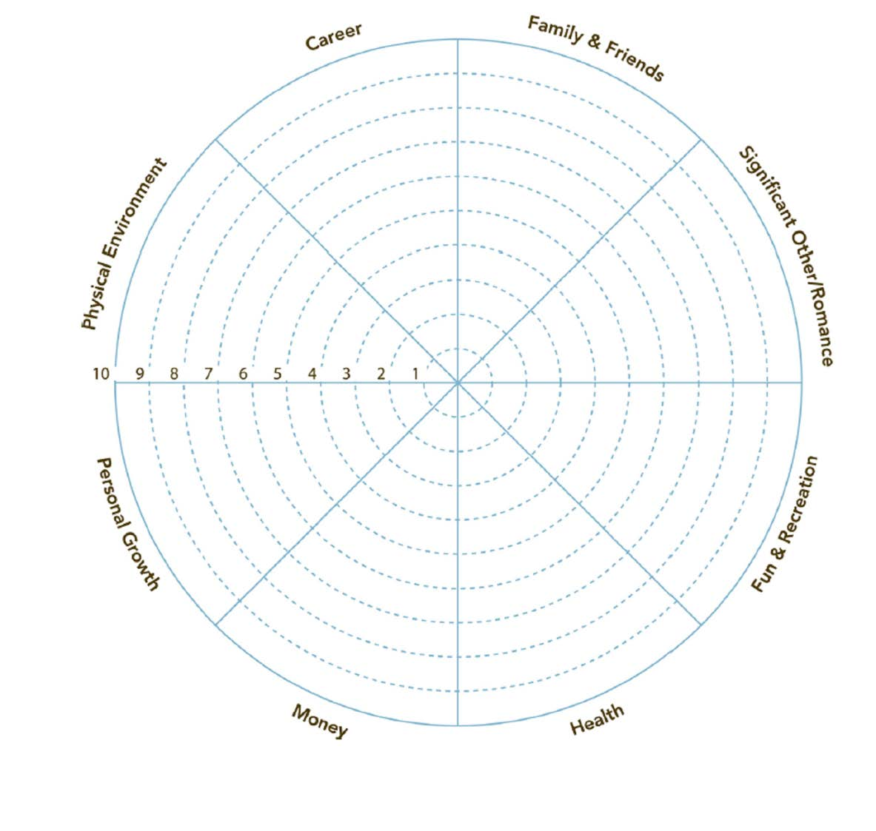

Reflection & Further Action
- Look at your Wheel of Life: is it smooth and balanced, or uneven and bumpy?
- Choose 1–2 low-scoring areas.
- Write down one small action you can take in the next 30 days to improve them.
Area | Current Situation | Action Step

